2.2 Product Functions.

CRM Software should support the following use cases:

|  |  |  |  |
| --- | --- | --- | --- |
| CLASS OF USE CASES | № | USE CASES | DESCRIPTION OF USE CASES |
| Related to System Authentication | 1 | **Login** | *Login into the CRM system* |
| 2 | **Change Password** | *Changes the login password* |
| Related to Activity Stream | 3 | **Post Message** | *Posts a Message to the Activity Stream* |
| 4 | **Delete Message** | *Delete Message from Activity Stream* |
| 5 | **Processes** | *Requests an Approval from Manager* |
| Related to Tasks | 6 | **New Task** | *Creates a task for execution* |
| 7 | **Execute Task** | *Executes the task* |
| 8 | **Finish Task** | *Finishes the task* |
| 9 | **Delete Task** | *Deletes the task* |
| Related to Calendar | 10 | **New Event** | *Creates an event in the Calendar* |
| 11 | **Delete Event** | *Deletes the event from the Calendar* |
| Related to CRM | 12 | **Create Contact** | *Creates a Contact in the CRM* |
| 13 | **Delete Contact** | *Deletes the Contact from the CRM* |
| 14 | **Create Company** | *Creates a Company in the CRM* |
| 15 | **Delete Company** | *Delete the Company from CRM* |
| 16 | **Create Activity** | *Creates an Activity* |
| 17 | **Finish Activity** | *Finishes an Activity* |
| 18 | **Delete Activity** | *Deletes an Activity* |
| Related to Information Display | 19 | **Display Message** | *Display information about the message* |
| 20 | **Display Request** | *Display information about the request* |
| 21 | **Display Task** | *Display information about the task* |
| 22 | **Display Event** | *Display information about the event* |
| 23 | **Display Contact** | *Display information about the contact* |
| 24 | **Display Company** | *Display information about the company* |
| 25 | **Display Activity** | *Display information about the activity* |

3 Specific Requirements

3.1 Functional Requirements.  
We describe the functional requirements by giving various use cases.

*Use cases related to System Authentication:*

*Use Case №1:* Login  
*Primary Actor*: User  
*Pre Condition*: Installed browser and active internet connection   
*Main scenario*:

1. User initiates browser
2. User specifies web address for accessing the CRM
3. User gives the login and password
4. System does authentication
5. Activity Stream is displayed

*Alternate scenario:*  
 4.1 Authorization fails – wrong username/password  
 4.1.1 Prompt the user that he typed the username/password wrong  
 4.1.2 Allow him to re-enter the username/password  
 4.2 Authorization fails – forgotten username/password  
 4.2.1 Prompt the user to enter his registered email  
 4.2.2 User receives an email with instructions about his login credentials

*Use Case №2*: Change password  
*Primary Actor*: User  
*Pre Condition*: User logged in   
*Main scenario*:

1. User goes to Bitrix24.Network Page from the profile menu located at the top
2. User goes to Edit Profile
3. User initiates “Change Password” functionality
4. User provides current password, new password and confirm new password
5. System displays message for successful change

*Alternate scenario:*  
 4.1 Authorization fails – wrong password  
 4.1.1 Prompt the user that he typed the password wrong  
 4.1.2 Allow him to re-enter the password  
 4.2 Authorization fails – new password and confirm new password do not match  
 4.2.1 Prompt the user that new password and confirm new password do not match  
 4.2.2 Allow him to re-enter the attributes.  
 4.3 Authorization fails – new password and confirm password are less than 6 chars  
 4.3.1 Prompt the user that password must be at least 6 characters  
 4.3.2 Allow him to re-enter new and confirm password

*Use cases related to Activity Stream:*

*Use Case №3:* Post Message   
*Primary Actor*: User  
*Pre Condition*: User logged in   
*Main scenario*:

1. User initiates “Post Message” functionality from Activity Stream
2. User enters message text
3. User specifies attachments (if necessary)
4. User specifies recipients
5. User posts the message
6. Message is created
7. All recipients receive notification

*Alternate scenario:*  
 5.1 Post Message Cancellation  
 5.1.1. User cancels Post Message functionality  
 5.1.2. Post Message canceled

*Use Case №4:* Delete Message   
*Primary Actor*: User  
*Pre Condition*: User logged in   
*Main scenario*:

1. User initiates “Delete Message” functionality from selected message
2. System displays a confirmation message
3. System displays a successful deletion message
4. Message is deleted

*Use Case №5:* Processes   
*Primary Actor*: User  
*Secondary Actor*: User - Approver  
*Pre Condition*: Users logged in   
*Main scenario*:

1. User initiates “Processes” functionality from Activity Stream
2. User selects type of needed approval
3. User specifies absence type
4. User specifies reasons
5. User sends the request approval
6. Request is created
7. Approver receives a notification about the request
8. User receives approvers decision

*Alternate scenario:*  
 5.1 Request Approval cancellation  
 5.1.1. User cancels Request Approval functionality  
 5.1.2. Request Approval canceled

*Use cases related to Tasks:*

*Use Case №6:* New Task  
*Primary Actor*: User  
*Pre Condition*: User logged in   
*Main scenario*:

1. User initiates the “New Task” functionality from Tasks (left pane, refer user screens in Appendix )
2. User enters a name for the task
3. User specifies responsible person
4. User specifies deadline for completion
5. User enters the task description
6. Task is created
7. System creates and assigns the task to the responsible person
8. System sends notification to the responsible person

*Alternate scenario:*  
 6.1 New Task cancellation  
 6.1.1. User cancels New Task functionality  
 6.1.2. New Task canceled

*Use Case №7:* Execute Task  
*Primary Actor*: User  
*Pre Condition*: User logged in   
*Scenario*:

1. User selects task from Tasks (left pane, refer user screens in Appendix )
2. User initiates the “Execute Task” functionality from the task itself
3. Task execution is started

*Use Case №8:* Finish Task  
*Primary Actor*: User  
*Pre Condition*: User logged in   
*Scenario*:

1. User selects task from Tasks (left pane, refer user screens in Appendix )
2. User initiates the “Finish Task” functionality from the task itself
3. System marks the task as completed

*Use Case №9:* Delete Task  
*Primary Actor*: User  
*Pre Condition*: User logged in   
*Main scenario*:

1. User selects task from Tasks (left pane, refer user screens in Appendix )
2. User initiates the “Delete Task” functionality from the task itself
3. System displays a confirmation message
4. Task is deleted

*Use cases related to Calendar:*

*Use Case №10:* New Event  
*Primary Actor*: User  
*Pre Condition*: User logged in   
*Main scenario*:

1. User initiates the “New Event” functionality from Calendar (left pane, refer user screens in Appendix )
2. User enters start and end time and sets reminders
3. User specifies event name and location
4. User specifies event description
5. User adds participants (if needed)
6. User submits the event
7. Event is created
8. System sends notifications to the participants
9. System sends reminders

*Alternate scenario:*  
 6.1 New Event cancellation  
 6.1.1. User cancels New Event functionality  
 6.1.2. New Task canceled

*Use Case №11:* Delete Event  
*Primary Actor*: User  
*Pre Condition*: User logged in   
*Main scenario*:

1. User selects the event from Calendar (left pane, refer user screens in Appendix )
2. User initiates the “Delete Event” functionality from the event itself
3. System displays a confirmation message
4. Event is deleted

*Use cases related to CRM:*

*Use Case №12:* Add Contact  
*Primary Actor*: User  
*Pre Condition*: User logged in   
*Main scenario*:

1. User initiates the “Add Contact” functionality from CRM/Contacts (left pane, refer user screens in Appendix )
2. User specifies first and last names of the contact
3. User specifies email
4. User specifies phone
5. User specifies Company (if necessary)
6. User specifies contact type
7. User specifies responsible person
8. A contact is created

*Alternate scenario:*  
 8.1. Add Contact cancelation  
 8.1.1. “Add Contact” functionality is canceled  
 8.2. Contact with the same information exists  
 8.2.1. System asks the user for different information  
 8.2.1. Contact is created  
 8.2.2. System asks the user for merging with existing contact  
 8.2.1. Contact is merged  
 8.2.3. System cancels the “Add Contact” functionality

*Use Case №13:* Delete Contact  
*Primary Actor*: User  
*Pre Condition*: User logged in   
*Main scenario*:

1. User selects the contact from CRM/Contacts (left pane, refer user screens in Appendix )
2. User initiates the “Delete Contact” functionality from the contact itself
3. System displays a confirmation message
4. Contact is deleted

*Use Case №14:* Add Company  
*Primary Actor*: User  
*Pre Condition*: User logged in   
*Main scenario*:

1. User initiates the “Add Company” functionality from CRM/Companies (left pane, refer user screens in Appendix )
2. User specifies company name
3. User specifies responsible person
4. User specifies company information
5. User associates employees / contacts (if present)
6. User submits the company form

*Alternate scenario:*  
 6.1. Add Company cancelation  
 6.1.1. “Add Company” functionality is canceled  
 6.2. Company with the same information exists  
 6.2.1. System asks the user for different information  
 6.2.1. Company is created  
 6.2.2. System asks the user for merging with existing Company  
 6.2.1. Company is merged  
 6.2.3. System cancels the “Add Company” functionality

*Use Case №15:* Delete Company  
*Primary Actor*: User  
*Pre Condition*: User logged in   
*Main scenario*:

1. User selects the company from CRM/Companies (left pane, refer user screens in Appendix )
2. User initiates the “Delete Company” functionality from the company itself
3. System displays a confirmation message
4. Company is deleted

*Use Case №16:* Create Activity  
*Primary Actor*: User  
*Pre Condition*: User logged in   
*Main scenario*:

1. User initiates the “Create Activity” functionality from CRM/Activities (left pane, refer user screens in Appendix )
2. User selects the activity type (new call or new meeting)
3. User specifies date and reminder
4. User specifies where/with information
5. User specifies subject and information
6. User specifies responsible person
7. An activity is created
8. System sends notification and reminders

*Alternate scenario:*  
 7.1 Create Activity cancellation  
 7.1.1. User cancels Create Activity functionality  
 7.1.2. Create Activity canceled

*Use Case №17:* Finish Activity  
*Primary Actor*: User  
*Pre Condition*: User logged in   
*Scenario*:

1. User selects the activity from CRM/Activities (left pane, refer user screens in Appendix )
2. User initiates the “Finish Activity” functionality from the activity itself
3. System marks the activity as finished

*Use Case №18:* Delete Activity  
*Primary Actor*: User  
*Pre Condition*: User logged in   
*Main scenario*:

1. User selects the activity from CRM/Activities (left pane, refer user screens in Appendix )
2. User initiates the “Delete Activity” functionality from the activity itself
3. System displays a confirmation message
4. Activity is deleted

*Use cases related to Information Display:*

*Use Case №19:* Display Message  
*Primary Actor*: User  
*Pre Condition*: User logged in   
*Scenario*:

1. Message is displayed in Activity Stream

*Use Case №20:* Display Request  
*Primary Actor*: User  
*Pre Condition*: User logged in   
*Scenario*:

1. Request is displayed in Activity Stream

*Use Case №21:* Display Task  
*Primary Actor*: User  
*Pre Condition*: User logged in   
*Scenario*:

1. User selects task from Tasks (left pane, refer user screens in Appendix )
2. System displays the Task information

*Use Case №22:* Display Event  
*Primary Actor*: User  
*Pre Condition*: User logged in   
*Scenario*:

1. User selects an event from Calendar (left pane, refer user screens in Appendix )
2. System displays the event information

*Use Case №23:* Display Contact  
*Primary Actor*: User  
*Pre Condition*: User logged in   
*Scenario*:

1. User selects a contact from CRM/Contacts (left pane, refer user screens in Appendix )
2. System displays the contact information

*Use Case №24:* Display Company  
*Primary Actor*: User  
*Pre Condition*: User logged in   
*Scenario*:

1. User selects a company from CRM/Companies (left pane, refer user screens in Appendix )
2. System displays the contact information

*Use Case №25:* Display Activity  
*Primary Actor*: User  
*Pre Condition*: User logged in   
*Scenario*:

1. User selects an activity from CRM/Activities (left pane, refer user screens in Appendix )
2. System displays the activity information

4. Appendix: User Screens

1. Login

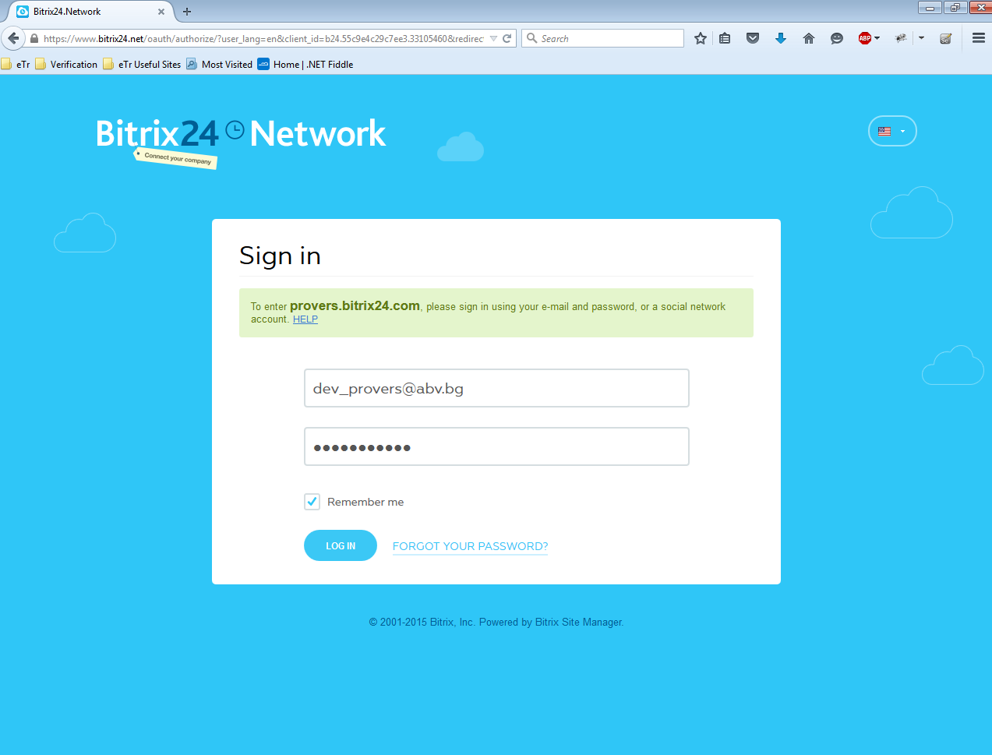

1. Bitrix Network

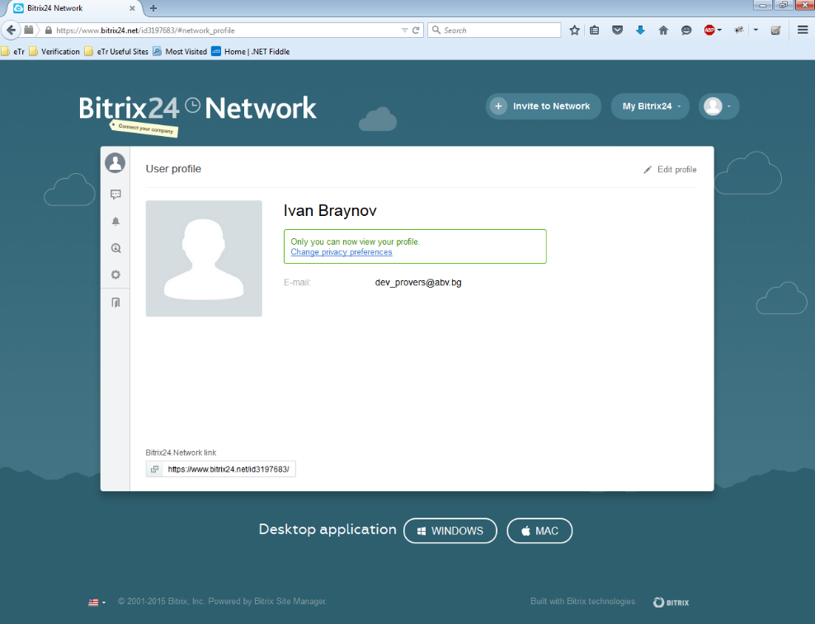

1. Activity Stream

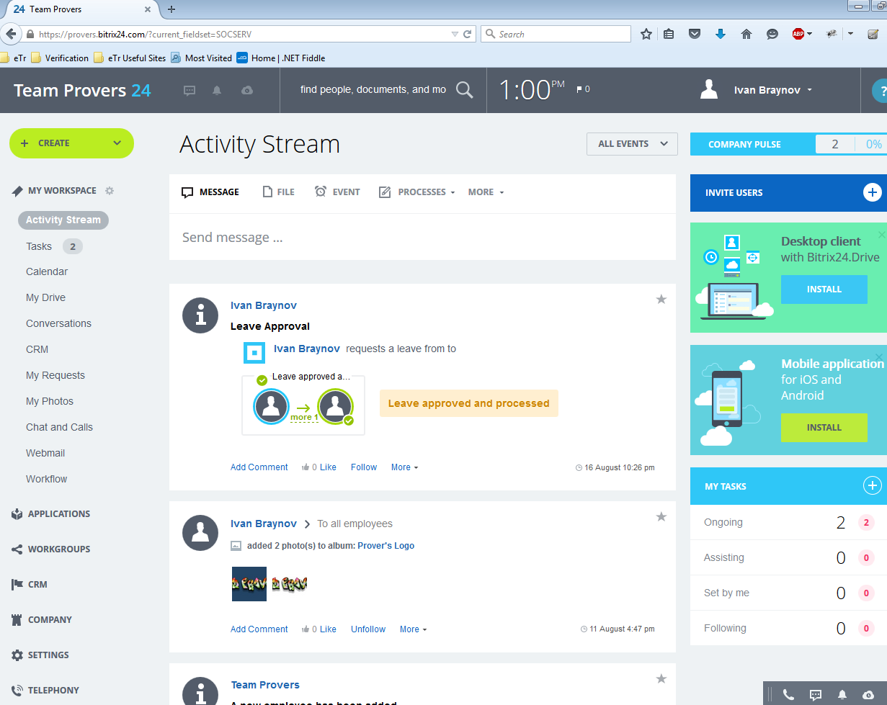

1. Tasks

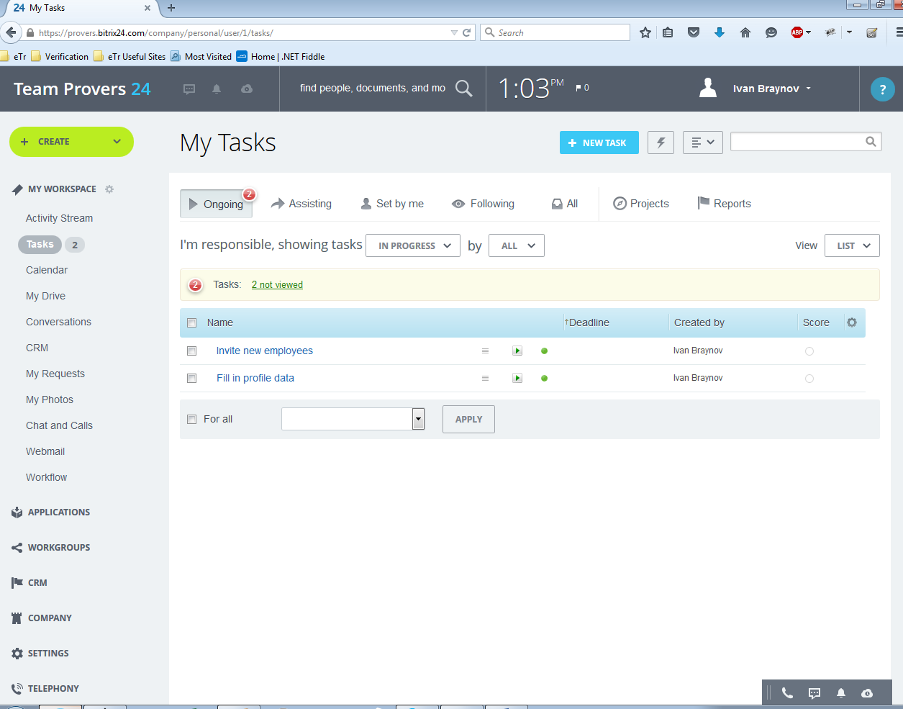

1. Calendar

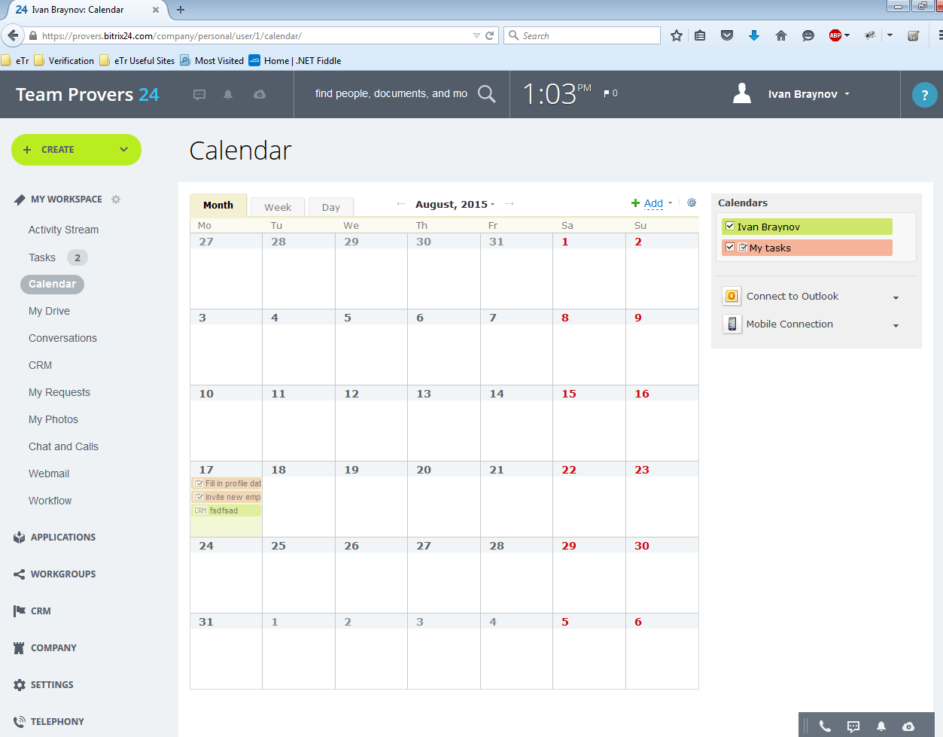

1. CRM

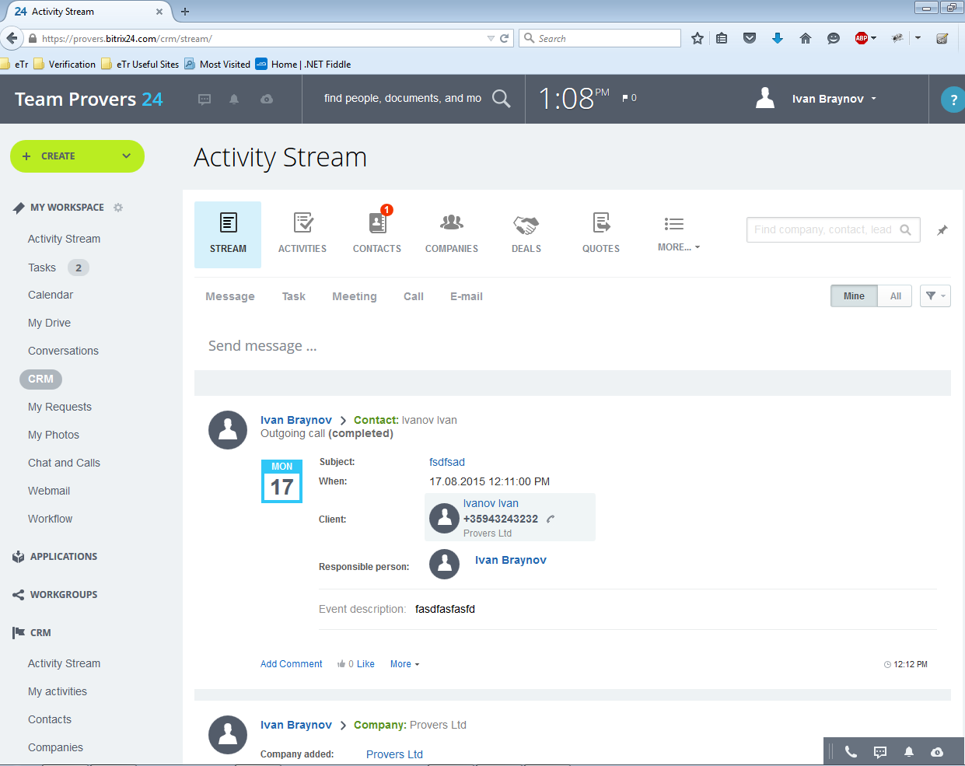

1. CRM/Contacts

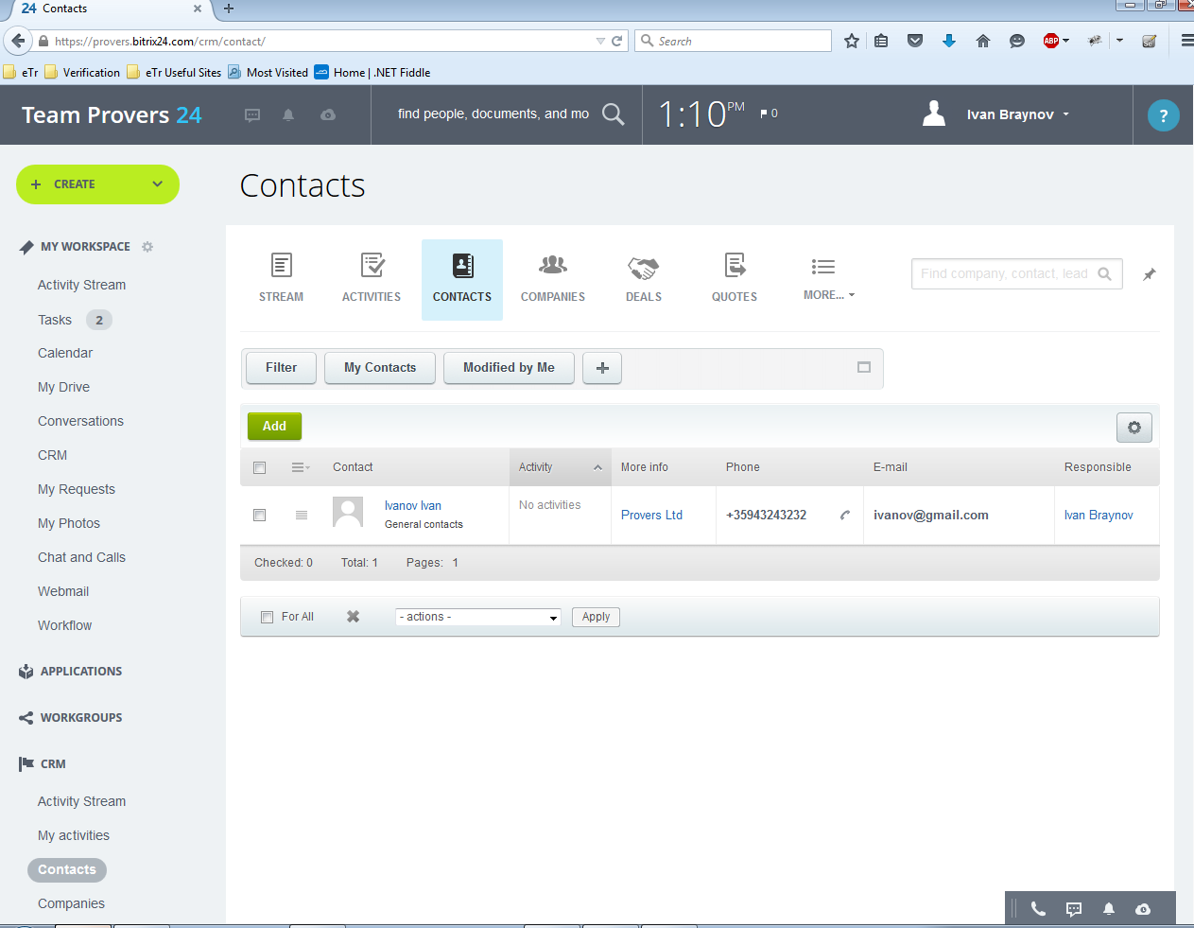

1. CRM/Companies

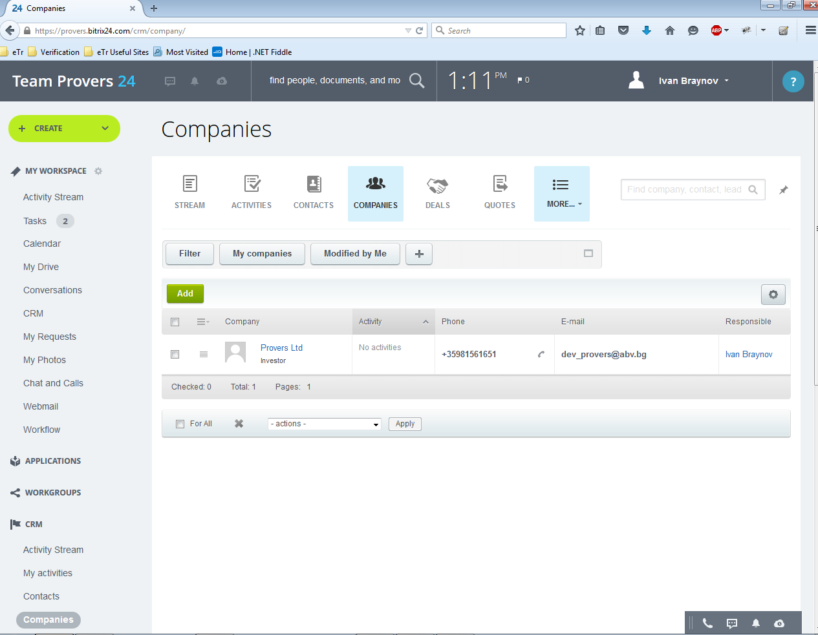

1. CRM/Activities

